8.46: a) Measured from the rear car, the position of the center of mass is, from Eq. (8.28), 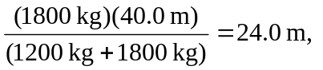which is 16.0 m behind the leading car.
